**CprE 381 – Computer Organization and**

**Assembly Level Programming**

**Lab – 7, Part B**

*In this part, you will learn to use the HI and LO special purpose registers and then experiment with floating point registers, instructions and finally complete a programming challenge. For simulation purposes, you may use SPIM or MARS (the java executable is provided to you on BBL).*

To run SPIM, please refer to Lab 4.

To run MARS, do the following:  
1. Open up a Command Prompt from the Start menu  
2. Navigate to the directory containing the MARS jar file  
3. Type **java -jar Mars<version>.jar** and hit the return key.  
  
   
**5. HI and LO registers:**These are special purpose registers used to store result of multiplication and division. They are not directly addressable. Their contents are accessed with special instruction **mfhi** and **mflo**, given below is their usage.  
  
 mfhi $rd

mflo $rd  
  
where rd is your destination register name.

Why do we need these registers? Suppose we want to multiply two 3-digit numbers. What's the maximum number of digits needed? Think about multiplying the two largest numbers possible, which is 999 times 999. This result is smaller than 1000 times 1000 which is 1,000,000 and uses 7 digits as a result. Thus, 999 times 999 must have 6 digits at most.

Thus we can say that multiplying an **m** digit number by an **n** digit number results in a **m + n** digit number, at most. Thus, when we multiply two 32 bit binary numbers, the result can be, at most, 32 + 32 = 64 bits. Thus the result of a multiplication or division operation cannot be stored in a regular 32 bit MIPS register. The lower 32 bits of the result is stored in **LO** and the upper 32 bits in **HI**. For division, **LO** stores the result of the integer division (i.e., the quotient), while **HI** stores the remainder. The operation is undefined if the divisor is 0.

Write an interactive program that inputs 3 integers (say A,B and C) and does the following:  
(i) computes their product(A*B*C) and displays the result (refer to Table 2 for system call codes)  
(ii) computes their sum (A+B+C), divides the sum by the first input (SUM / A) and displays the quotient and the remainder.  
Submit your code and screenshot(s) of your simulation containing the Register values.

**6. Floating Point Arithmetic**

The floating-point unit (also known as coprocessor 1) has 32 floating-point registers. It operates on single precision (32-bit) and double precision (64-bit) floating point numbers. Numbered as $f0, $f1, …, $f31, these registers are 32 bits wide. Thus, each register can hold one single-precision floating-point number. Using the FPU for single precision floating point numbers is straightforward. What happens to double precision floating point arithmetic which require 64 bits? The 32 single-precision registers are grouped into 16 double-precision registers. The double-precision numbers are stored in an even-odd pair of registers ($f0-$f1, $f2-$f3 and so on), but we only refer to the even-numbered register. For example, if a double precision number is stored in $f2, it is actually stored in registers $f2 and $f3.

The following table (taken from your textbook) lists some commonly used MIPS floating point instructions:  
  
  
 **Table 1 MIPS FP instructions**

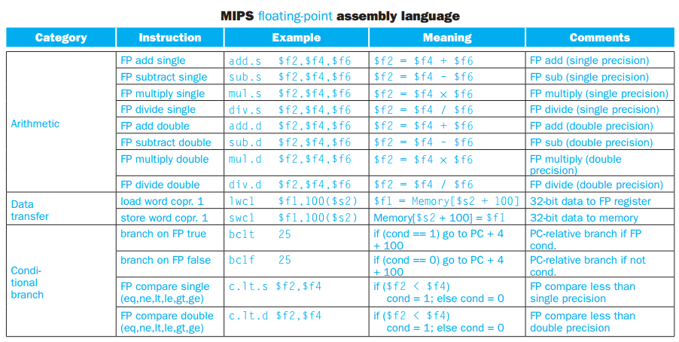

**Moving data from register to register:**We use the **mfc1** (move from coprocessor1) instruction to move data from a floating point register to integer register, the **mtc1** (move to coprpocessor1) instruction to move data to a floating point register and the **mov.s** to simply move data within single point floating point registers. The following examples illustrate their use.

mov.s $f0, $f2 #move between FP registers

mfc1 $t1, $f2 #move from FP registers

mtc1 $t1, $f2 #move to FP registers

Write an assembly code to multiply two (4x4) matrices A and B and store the result in C (also a matrix obviously). Populate A and B with **double precision floating point** values. The multiplication should happen in column-major order. Use **system calls** for printing your result to the console and for taking inputs from user. Submit your code and also a screenshot of your SPIM or MARS simulation (register values). Refer to page 215 of your textbook for an example. Table 2 below (taken from your textbook) lists system call codes for reference.

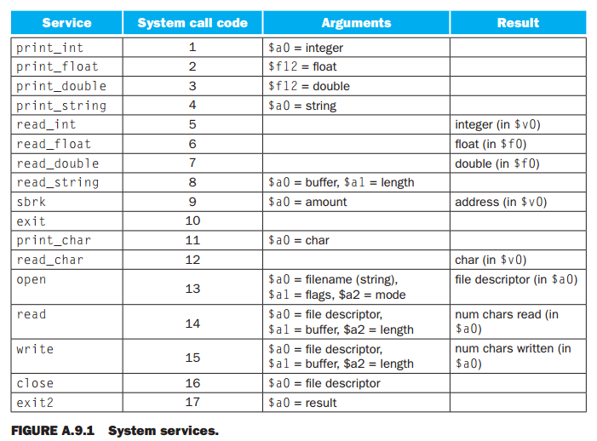

**Table 2 System Call Codes**

**Submission**All submissions are through blackboard. You may edit this document with your answers or create a separate document. If you are submitting multiple files, their names must be self-explanatory. Put all files into a zip file (*Lab-7b-submit.zip*) before uploading.